Promotion and Fundraising Guidelines – to be read before applying for a Philanthropic Loan and to be added to the Philanthropic Loan Agreement
Intro
Our philanthropic lenders are trying to achieve maximum impact with their money. They are putting considerable trust in the organisations that they support, and expect those organisations to pay them pack asap so that they can use that money for other purposes, including hopefully supporting more projects.
It is vital that organisations benefitting from a philanthropic loan bear that in mind and do not see repaying the loans as a low priority.
This note sets out the steps your organisation agrees to take, in return for offer of a philanthropic loan, to:-
- Fundraise vigorously to try to reduce the loan required for your project. So if the loan is for:-
  - Acquisition of land, to reduce the loan required by completion of purchase of the land;
  - Project costs, to reduce the need for further tranches of loan towards those costs; and
- Help promote the overall Funding Nature project and the concept of philanthropic loans generally.
The mission is to restore as much land as possible to nature and people through the Funding Nature project, and to help kickstart as many projects as possible, and that means that we need to tell people about the Funding Nature project to try to inspire others to get involved as a donor or philanthropic lender.
Note – Julia Davies publicises her involvement to try to attract more philanthropic lenders and donors. Some lenders want to remain anonymous – so it’s really important to check with lenders before using their name in any publicity.
In this guidance the Agreed Period means the date from when an offer of a philanthropic loan is made until whichever period is longer of:-
- the period up until the philanthropic loans which help you acquire the site/progress the project have been repaid
- the period up until the 3rd anniversary of completion of the acquisition of the site/commencement of the project.
Be prepared
Once a philanthropic loan has been offered for your project please start preparing right away to fundraise to reduce it and to publicise it. In fact, when applying for the loan you should show that you are already doing all you can to get the funds elsewhere. Where the loan is to assist with buying land, don’t wait until the purchase is completed before involving your marketing and fundraising team.
When you first announce the project/acquisition is potentially when you get the best publicity and have the best chance to attract people:-
- To your fundraising appeal to help reduce the loan needed and then pay off the loan received, and;
- To the Funding Nature website pages and the We Have The POWER website so that they can find out more about philanthropic loans and becoming a major donor.
Note – if the funds to repay a loan are coming from a non-public fundraising channel (eg a grant or Local Authority funding) and you do not intend to launch a pubic-facing fundraiser you need to make that clear at the point of applying for a loan.
Fundraising Appeal wording re loan on your dedicated fundraising page and on the webpage for the site:
Once your offer on the land has been accepted or you have started work on your project – use wording covering the following to explain why you still need to fundraise urgently:-
- “We have been able to make an offer of [£insert amount] to buy [insert name of Property] on the back of a generous offer of a philanthropic loan from a group of philanthropic lenders [including Julia Davies of We Have The POWER], and we are delighted to say that our offer has been accepted.”
- “We still need to keep fundraising – because [Julia has/the philanthropic lenders have] loads of projects needing [her/their] support – and the more she lends us the less [she/they] can lend to others.”
- Where Julia is the lender use – “Julia is an environmental campaigner, lawyer, philanthropist and true impact investor who uses her personal funds to enable charitable projects (including land acquisitions for nature restoration) to progress. Julia is kindly supporting our acquisition but on the understanding that we will do all we can to reduce the loan from her needed at completion and then to pay back any loan she does provide as a priority. We can’t progress work on the site until the loan is repaid. Equally Julia can’t support the many projects which contact her regularly, until her commitment to this project is substantially reduced.”
- Where others are the lenders - “The philanthropic lenders use their personal funds to enable charitable projects (including land acquisitions for nature restoration) to progress. They are kindly supporting our acquisition but on the understanding that we will do all we can to reduce the loan from them needed at completion and then to pay back any loan they do provide as a priority. We can’t progress work on the site until the loan is repaid. Equally until their commitment to our project is substantially reduced the lenders are less able to help other projects.”
- For non-land acquisition projects - Julia is an environmental campaigner, lawyer, philanthropist and true impact investor who uses her personal funds to enable charitable projects (including land acquisitions for nature restoration) to progress. Julia is kindly supporting our project but on the understanding that we will do all we can to pay back any loan she does provide as a priority. We can’t expand and grow the project until the loan is repaid. Equally Julia can’t support the many projects which contact her regularly, until her commitment to this project is substantially reduced.”
Avoid having to return funds if you raise too much or too little
Whenever fundraising for a specific purpose always consider what will happen if you raise more or less than you need. If you aren’t careful you can end up having to offer donations back to donors but this is easily avoided by using appropriate wording which explains that any money you can’t use for the specific purpose identified will be used for the other work of your charity. So use wording like:-
“Any funds raised will be used to buy East Wood if our offer on the land is accepted or to fund work on the site or other projects to restore nature locally.
So if our offer for East Wood isn’t successful rest assured that your donation will not go to waste. We will use it for other vital nature restoration work or towards another purchase.
Equally, if we are lucky enough to raise more money than we need for this purchase this extra will just help create even more impact for nature by funding our overall mission to help nature recover.”

Materials to create
Once the philanthropic loan has been offered please:-
- Provide Julia with the following to use:-
  - a draft LinkedIn post (based on the template and examples below) for me to use to announce the loan and promote your fundraising page for the Project. This will also go on the We Have The POWER website on the Philanthropic loan pages
  - content to add to the Philanthropic loan/Philanthropic loans in practice section of the We Have The POWER website here, eg “East Waste Drove, Somerset – acquired by Somerset Wildlands March 2022 – 12 acres View more”
- Create and maintain a webpage for the site incorporating:-
  - An overview of the site and, once it has been acquired, news about how nature is recovering, community engagement etc
  - A Funding Nature Acknowledgement - see example below
  - A mechanism for people to donate towards reducing/repaying the loan. Note – this site specific appeal is only a requirement until the loan has been repaid.

Once you have acquired the site please :-
- Acknowledge the philanthropic loan support and include a Funding Nature Acknowledgement (see below):-
  - In any social media to announce the acquisition
  - On any on site signage which references funding support for the site, and in any case, on at least one prominent sign on the site.
- Acknowledge the philanthropic loan support and include a Funding Nature Acknowledgement (see below) in any press release:-
  - to announce the acquisition
  - about the site issued during the Agreed Period (unless it’s really not appropriate to do)
- Provide each philanthropic lender who helped you acquire the site with a framed photo of the site as a thankyou – incorporating:-
- your logo
- We Have The POWER logo
- Following message
“Thank you for helping [name of your organisation] acquire [name of site]
[number of] acres, [year]”
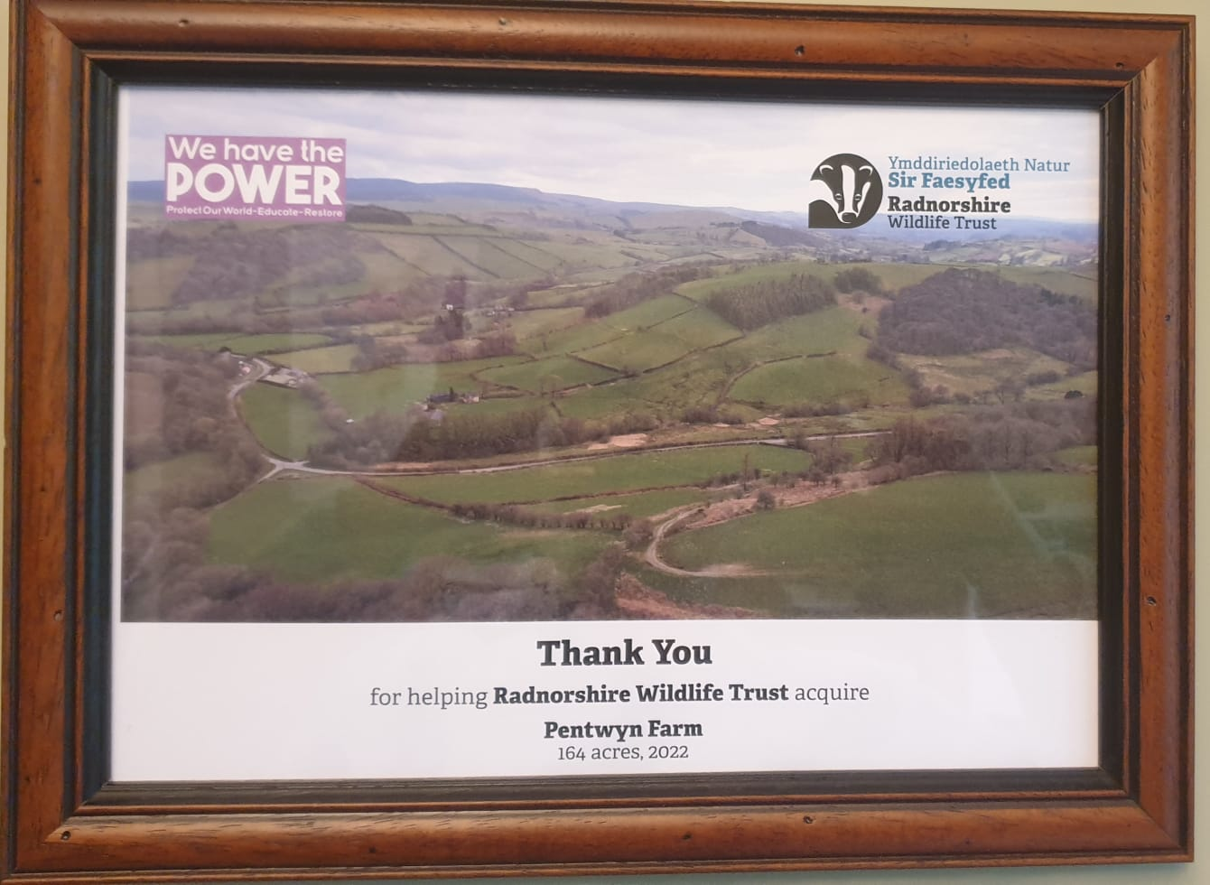

Funding Nature Acknowledgement – to keep on your website site for at least the Agreed Period

(Note also fundraising wording to use as shown above)

Where Julia is sole lender –

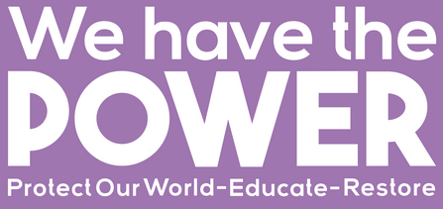 | Acquisition of this site was made possible by a philanthropic loan from Julia Davies of We Have The POWER, through her Funding Nature Project. You can find out about other sites acquired through the Funding Nature project here.

Where Julia is one of several lenders.

Acquisition of this site was made possible by philanthropic loans from a group of individuals who share a passion for restoring land to nature and people. You can find out about other sites acquired through the Funding Nature project here and here.

For projects

This project was catalysed by a philanthropic loan from Julia Davies through her We Have The POWER project.

Linkedin/website post

Please supply wording and images for a suggested draft post for us to use on LinkedIn and on the We Have The POWER website to promote the philanthropic loan support for the acquisition/ project. In creating the post note:-

- Linked In Posts have a limit of up to 1300 Characters (with spaces) but please note that shorter posts often work better
  - This word count includes hashtags or links.
  - Note you can’t put text as links within the post – links have to be the full url.
- Have a look at some of the posts linked to at the bottom of our philanthropic lending page to understand what we are looking for.
- Creating the first draft of the post gives you the opportunity to get your message across but we may then edit the post to match our style and our overall Funding Nature objectives.
- Include appropriate hash tags plus tags to relevant key people.
- End post with a link to your fundraising page for the site/project

Example posts:

Example 1
The Somerset Levels in the South West was once the UK’s Danube Delta, a vast wild wetland, teeming with life – from pelicans to #beavers, sturgeon to #wildcats. Somerset Wildlands’ aim is to return some of that life through a process of decentralised #rewilding. By acquiring pieces of land large and small, it will create lightly managed wild stepping-stones as refuges and corridors for #nature.
So by the 3rd acquisition in my Funding Nature project, I’ve provided @Somerset Wildlands with a philanthropic loan to acquire a 12-acre field formerly grazed by sheep, and very close to an existing Somerset Wildlands wildlife stepping stone. Despite being small, the neighbouring site is already used by a host of wildlife including otters, great egrets, marsh harriers and grass snakes, and that wildlife now has another twelve-acre refuge to spread out to.
Find out more at: [webpage address]
Tags
#rewilding #wildlife #conservation #biodiversity #wetlands #beavers #wildcats

Example 2
Funding Nature acquisition no. 9 completed yesterday, bringing total acres restored to nature and people to 2,042 – with 5 more acquisitions in progress!
Myself and 3 other philanthropic lenders helped Bedfordshire, Cambridgeshire and Northamptonshire Wildlife Trust secure Strawberry Hill, a very special site much of which has already been left to #rewild for the past 25 years under the Countryside Stewardship Scheme.
375-acre Strawberry Hill is the largest area of scrub and young #woodland in the region, a site rich in nature - a recent #bird survey showed healthy populations of nightingales, willow warblers, whitethroats and garden warblers, with ideal habitat for turtle doves. This is a remarkable opportunity to protect some unique habitat whilst creating a wild visitor destination.
Find out more about BCNWT’s vision for this unique site here: [webpage address]
#fundingnature #wildlife #sustainableinvesting

